Math 4 Honors Name ______________________________

Lesson 6-2: *The Derivative at a Point* Date ______________________________

**Learning Goals:**

* *I can use the definition of derivative to find f’(x) for any function f(x) and any value of x.*
* *I can use the derivative of a function to solve problems.*

I. The projectile referred to in Investigation 1 had a position equation oh *h*(*t*) = 960*t* – 16*t*2. Part of the path of the projectile is shown below. In addition, secant lines representing your computations from parts a – d have been drawn.

1. What is happening to the distances between the points on the curve that are connected by the

secant lines as Δ*t* gets smaller?

Eventually the 2 points become one; what results is a **tangent line**. *The slope of the tangent line is the instantaneous velocity of the object at that point in time.*

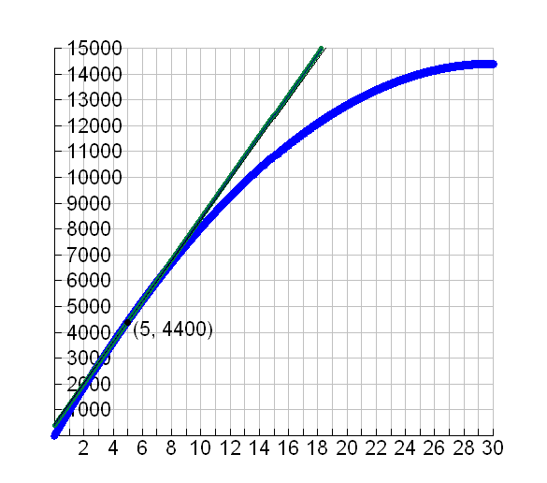 **tangent line** (We will talk more about tangent lines as a class.)

Calculate the slope of the tangent line when *t* = 5.

Look back at your limit statement from investigation 1. Do the numbers match?

Height (ft)

Time (seconds)

1. The example in part A illustrates the geometric definition of **instantaneous velocity**. Here is the

algebraic definition:

Suppose an object is moving so that each time *t* is at a position *f*(*t*) along a line. The **instantaneous velocity** is the limit as Δ*t* → 0 of the average velocity of the object between times *t* and *t* + Δ*t.* In symbols, this means:



**Instantaneous Velocity =**

**Recall:** The formula for the average velocity of the projectile from Investigation 1: ***AV* = 960 – 32t – 16Δ*t*** Use the formula to find the *instantaneous velocity* of the projectile at *t =* 5 seconds.

Finish: *IV* = 

= OVER 🡪

C. The graph below shows the distance *d* in miles traveled by a car in *t* hours after it begins a trip. Find the **instantaneous velocity** of the car at *t* = 1 hour.



II. The previous examples used the quantity . This quantity arises in

many other settings & so it has been given a special name. It is called the **derivative of *f* at *x.***

**Definition:** The **derivative of a real function *f* at *x,*** denoted***f*’(*x*)** is:



*Note: The function must be continuous & smooth at point x.*



**Example:** Let

*Method A: Algebraic Method B: Graphical*

Follow these steps:

1. Carefully draw the parabola.

2. Use a ruler to draw a tangent line to the parabola

where *x=* 3. (You will have to “eyeball” it.)

3. Calculate the slope of the tangent line.

Follow these steps:

1. Use the definition to derive a formula for *f.*’

2. Evaluate your formula when *x=* 3.

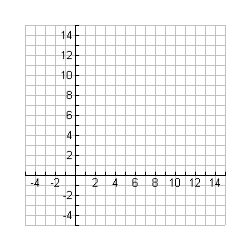

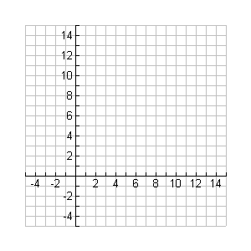

***Your answers using both methods should yield the same results….***

*[](http://www.google.com/imgres?hl=en&safe=active&biw=1280&bih=929&tbm=isch&tbnid=Nws9YnZ4YbQcpM:&imgrefurl=http://compasstech.com.au/TNS_Authoring/poly.html&docid=qzgNDPMLLAl4NM&imgurl=http://compasstech.com.au/TNSINTRO/TI-NspireCD/HTML_files/Nspire_logo.jpg&w=913&h=210&ei=nOw4UfGwJvCLyAHf_IHQBw&zoom=1&ved=1t:3588,r:8,s:0,i:103&iact=rc&dur=603&page=1&tbnh=60&tbnw=264&start=0&ndsp=22&tx=110&ty=20)*More fun!!!!: *Method*

Follow these steps:

1. Graph the function: 

2. Adjust the window to see the parabola.

3. Press **[MENU]→8: Geometry→1 :Points & Lines→7: Tangent** to open the Tangent Line tool.

4. Click [CLICK] on the function graph, then press [CLICK] again to construct the tangent line.

5. Press [ESC] to exit the Tangent Line tool.

6. Drag the point of tangency until the *x*-coordinate = 3.

7. Select the tangent line and then choose **8: Geometry→3: Measurement→3: Slope**.

8. Press [ESC] to exit the Slope tool.

*What is the slope of the tangent line?*

Math 4 Honors Name ___________________________

HW: Lesson 6-2: *The Derivative at a Point* Date __________________________



*Use the algebraic definition to find the equation of the derivative for each function.*

*Show your work on another piece of paper.*

**

*Use the algebraic definition to find the equation of the derivative for m(r).*

*Show your work on another piece of paper.*

**

**

*Use the algebraic definition to find the equation of the derivative for h(t).*

*Show your work on another piece of paper.*

OVER 🡪

**

**

*Use the algebraic definition to find the equation of the derivative for h(t).*

*Show your work on another piece of paper.*

**

**

**